DATABASE DESIGN

Flower_Details :-

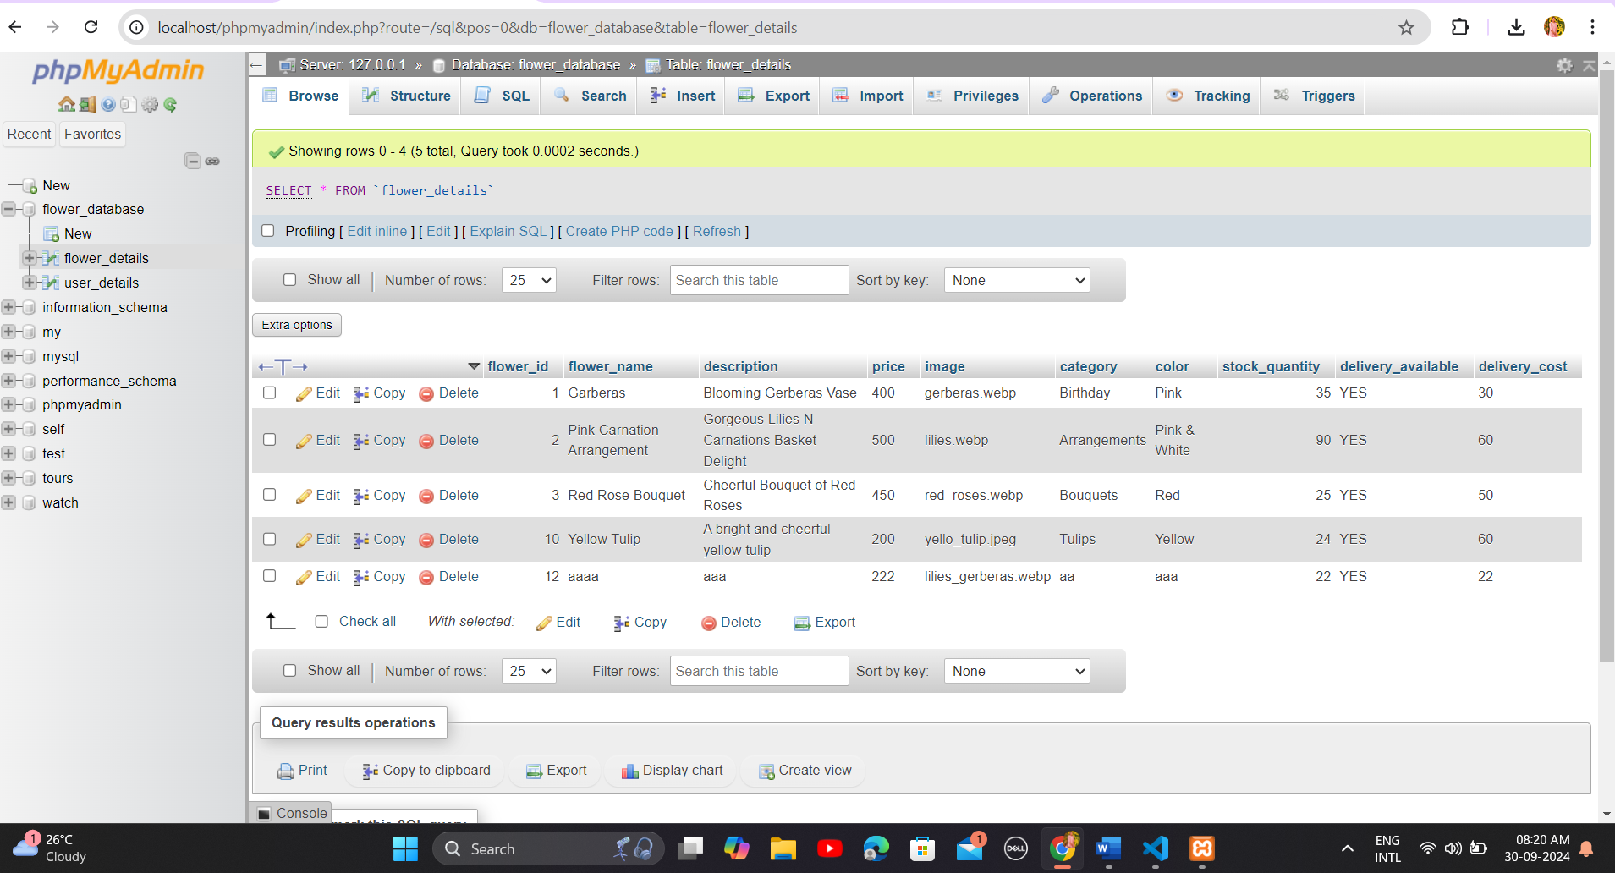

User_Details :-



Connection File

<?php

$servername="localhost";

$username="root";

$pwd="";

$db="flower";

$con=mysqli_connect($servername,$username,$pwd,$db);

?>

login.php

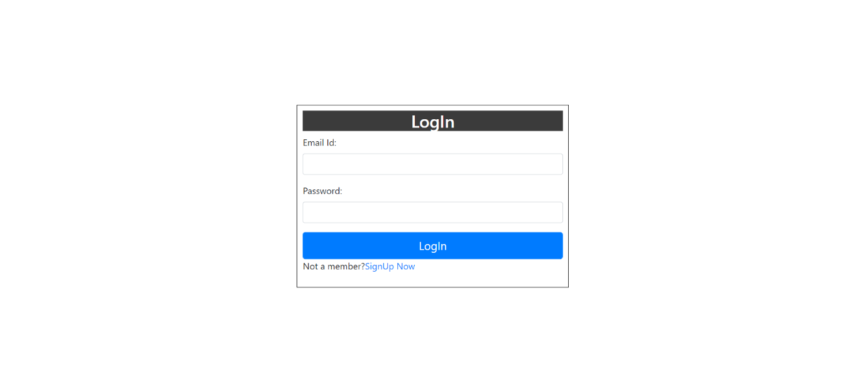

<?php

session_start();

$con = mysqli_connect("localhost", "root", "", "flower_database");

if (isset($_POST['submit'])) {

    $_SESSION['mail'] = $_POST['mail'];

    $_SESSION['pwd'] = $_POST['pwd'];

    $sql = "select * from user_details where email='{$_SESSION['mail']}'";

    $qry = mysqli_query($con, $sql);

    $row = mysqli_fetch_array($qry);

    if($_POST['mail']=="" && $_POST['pwd']==""){

        echo "<script>alert('Please Enter Email id and Password.');</script>";

    }

    elseif ($_SESSION['mail'] == 'admin@gmail.com' && $_SESSION['pwd'] == 'admin') {

        echo "<script>window.location.href='admindashboard.php';</script>";

    } elseif ($_SESSION['mail'] == $row['email'] && $_SESSION['pwd'] == $row['password']) {

        echo "<script>window.location.href='user_panel.php';</script>";

    } else {

        echo "<script>alert('Enter valid Email id and Password.');</script>";

    }

?>

Admin Module

adminDashboard.php

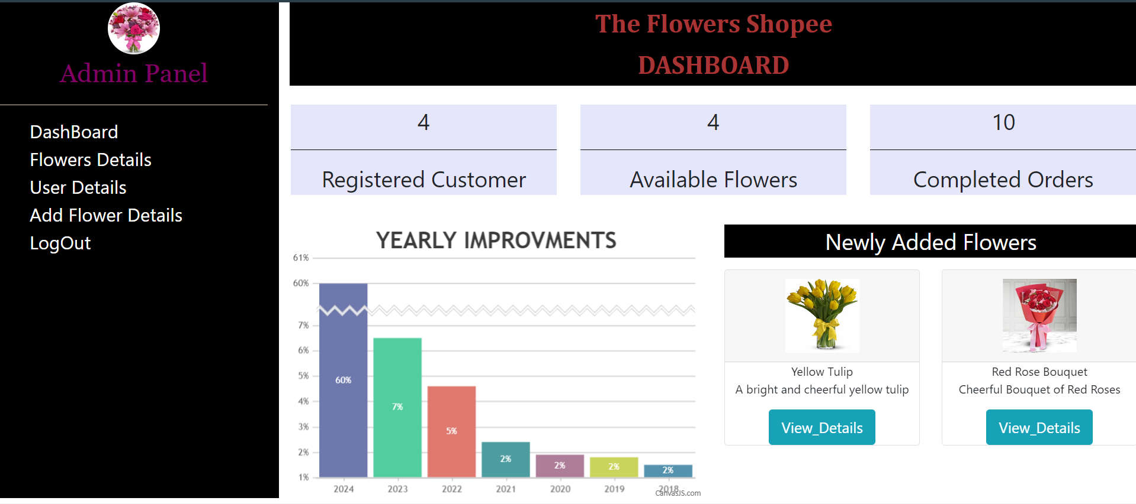

<?php

include('config.php');

$sql1 = mysqli_query($con, "select count(user_id) from user_details");

$sql2 = mysqli_query($con, "select count(flower_id) from flower_details");

$qry = mysqli_query($con, "select * from flower_details order by flower_id desc limit 2");

$total = mysqli_fetch_array($sql1);

$total2 = mysqli_fetch_array($sql2);

?>

<?php

while ($t3 = mysqli_fetch_array($qry)) { ?>

                                <div class="col-sm-6 text-center">

                                    <div class="card">

                                        <div class="card-header">

                      <img src="upload_flower/<?php echo $t3['image']; ?>" alt="image" height="100px" width="100px">

                                        </div>

                                        <div class="card-content">

                                            <p><?php echo $t3[1]; ?><br>

                                                <?php echo $t3[2]; ?></p>

                                            <a href="flower_details.php?fid=<?php echo $t3[0]; ?>"><button type="button" class="btn btn-lg btn-info">View_Details</button></a>

                                        </div>

                                    </div>

                                </div>

<?php } ?>

add_flower_details.php

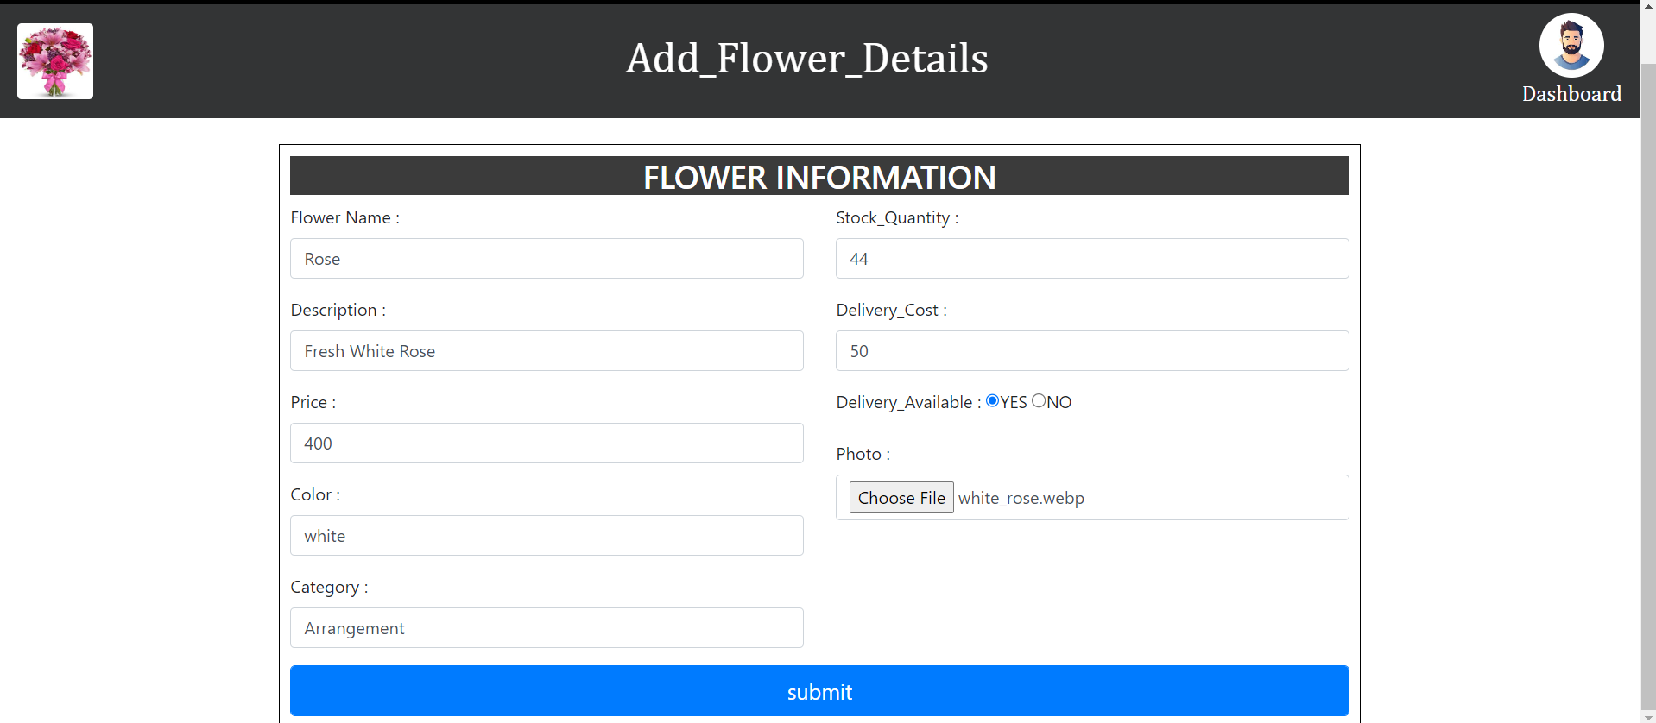

<?php

$con = mysqli_connect("localhost", "root", "", "flower_database");

if (isset($_POST['submit'])) {

    if (!empty($_POST['fname']) && !empty($_POST['desc']) && !empty($_POST['color']) && !empty($_POST['price']) && !empty($_POST['stock']) && !empty($_POST['category']) && !empty($_POST['da']) && !empty($_POST['dcost'])) {

        $fname = $_POST['fname'];

        $desc = $_POST['desc'];

        $price = $_POST['price'];

        $color = $_POST['color'];

        $category = $_POST['category'];

        $stock = $_POST['stock'];

        $da = $_POST['da'];

        $dcost = $_POST['dcost'];

        $img = $_FILES['img']['name'];

        $tmp_img = $_FILES['img']['tmp_name'];

        move_uploaded_file($tmp_img, "upload_flower/$img");

        $qry = mysqli_query($con, "INSERT INTO `flower_details`(`flower_name`, `description`, `price`, `image`, `category`, `color`, `stock_quantity`, `delivery_available`, `delivery_cost`) VALUES ('{$fname}','{$desc}','{$price}','{$img}','{$category}','{$color}','{$stock}','{$da}','{$dcost}')");

        echo "<script>alert('Your Data successfully Registered.');

            window.location.href='flower_details.php';

            </script>";

    } else {

        echo "<script>alert('please Insert all the required data.')</script>";

    }

}

?>

user_details.php

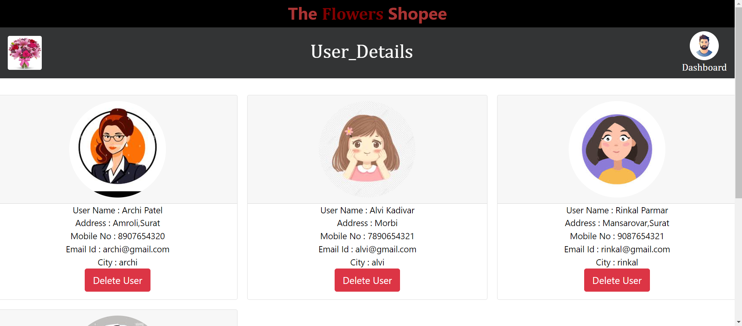

<?php

include('config.php');

$qry = mysqli_query($con, "select * from user_details");

?>

<?php

            $qry = mysqli_query($con, "select * from user_details");

            while ($row = mysqli_fetch_array($qry)) { ?>

                <div class="col-sm-4 text-center">

                    <div class="card">

                        <div class="card-header">

                            <img src="upload_img/<?php echo $row['photo']; ?>" alt="image" height="200px" width="200px" class="rounded-circle img-responsive">

                        </div>

                        <div class="card-content">

                            <p>User Name : <?php echo $row[1] ?><br>

                                Address : <?php echo $row[2] ?><br>

                                Mobile No : <?php echo $row[3] ?><br>

                                Email Id : <?php echo $row[4] ?><br>

                                City : <?php echo $row[5] ?><br>

                                <a href="delete_user.php?uid=<?php echo $row[0];?>">

                                    <button type="button" class="btn btn-lg btn-danger">Delete User</button>

                                </a>

                            </p>

                        </div>

                    </div>

                </div>

            <?php } ?>

flower_details.php

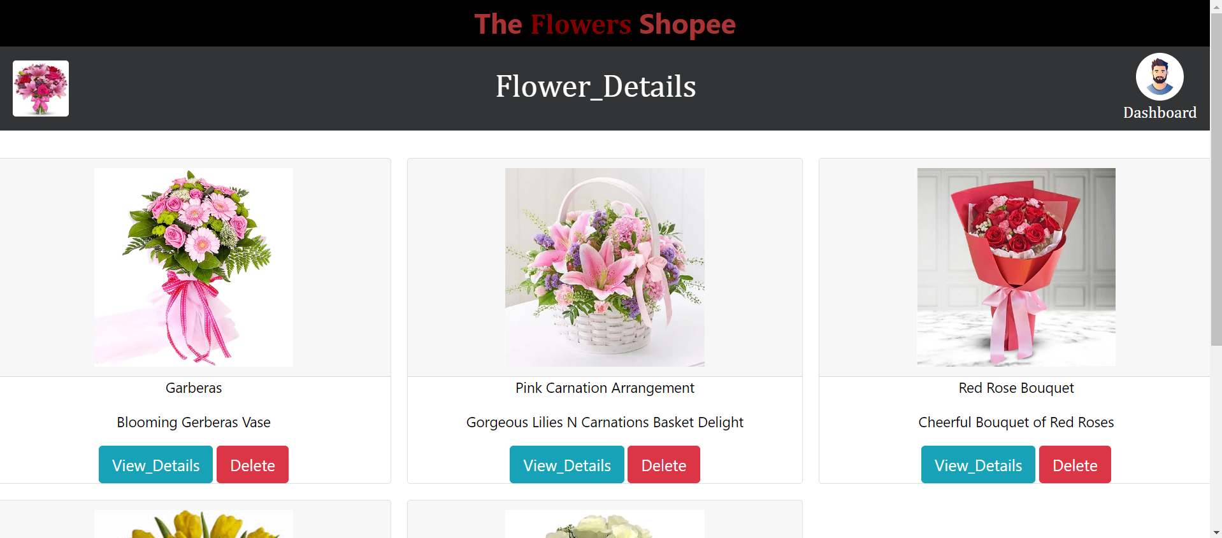

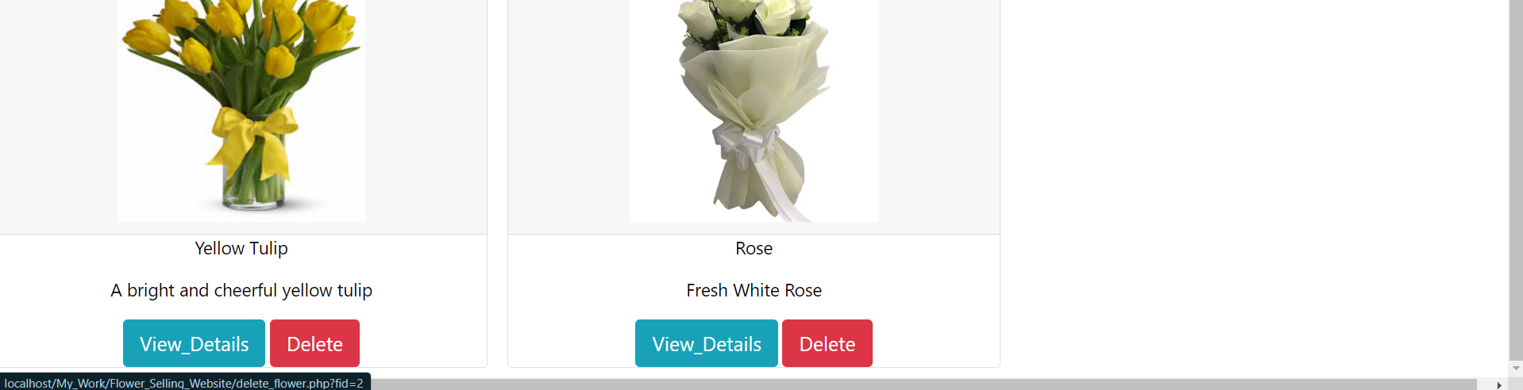

<?php

include('config.php');

$qry = mysqli_query($con, "select * from flower_details");

?>

<?php

                while ($row = mysqli_fetch_array($qry)) { ?>

                    <div class="col-sm-4 text-center">

                        <div class="card">

                            <div class="card-header">

                                <img src="upload_flower/<?php echo $row['image']; ?>" alt="image" height="250px" width="250px">

                            </div>

                            <div class="card-content">

                                <p><?php echo $row[1]; ?></p>

                                <p><?php echo $row[2]; ?></p>

                                <a href="update_flower.php?fid=<?php echo $row[0]; ?>"><button type="button" class="btn btn-lg btn-info">View_Details</button></a>

                                <button type="button" class="btn btn-lg btn-danger" onclick="return confirm('You Want to Delete This Flower Information ?');"><a href="delete_flower.php?fid=<?php echo $row[0]; ?>">Delete</button></a>

                            </div>

                        </div>

                    </div><?php } ?>

update_flower.php

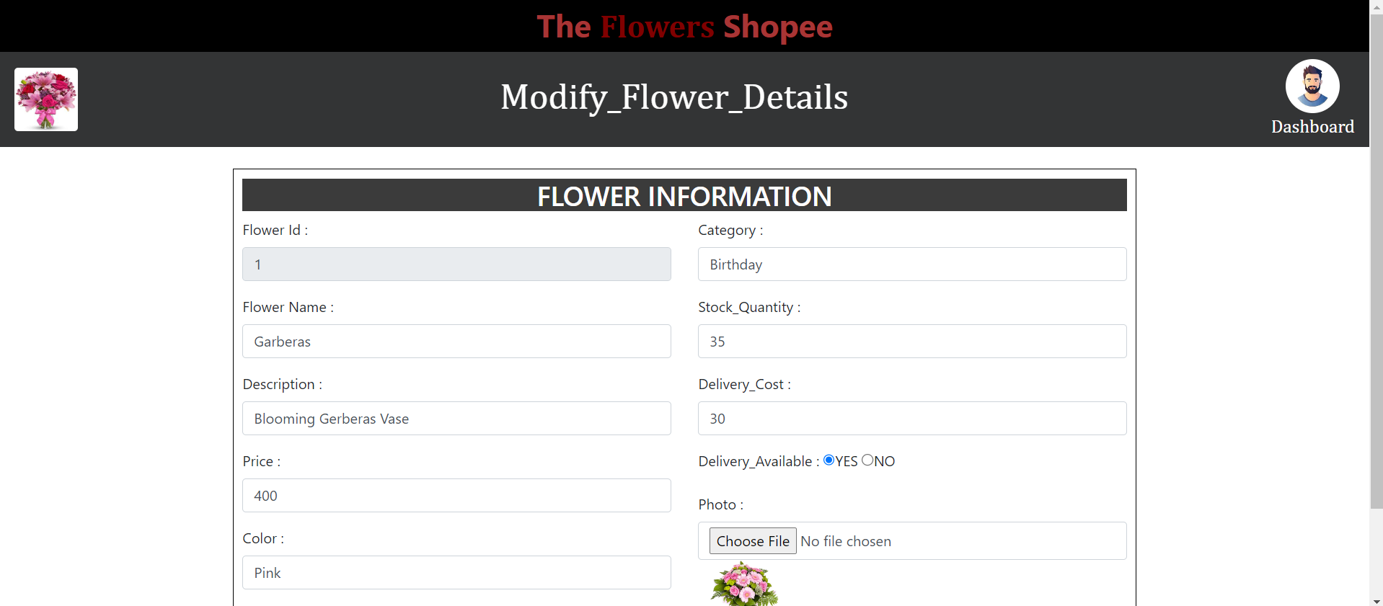



<?php

include('config.php');

if (isset($_REQUEST['fid'])) {

    $fid = $_REQUEST['fid'];

    $qry = mysqli_query($con, "SELECT * FROM `flower_details` WHERE flower_id=$fid");

    $row = mysqli_fetch_array($qry);

}

if (isset($_POST['submit'])) {

    if (!empty($_POST['fname']) && !empty($_POST['desc']) && !empty($_POST['color']) && !empty($_POST['price']) && !empty($_POST['stock']) && !empty($_POST['category']) && !empty($_POST['da']) && !empty($_POST['dcost'])) {

        $fname = $_POST['fname'];

        $desc = $_POST['desc'];

        $price = $_POST['price'];

        $color = $_POST['color'];

        $category = $_POST['category'];

        $stock = $_POST['stock'];

        $da = $_POST['da'];

        $dcost = $_POST['dcost'];

        $img = $_FILES['img']['name'];

        $old = $_REQUEST['old_img'];

        $temp_img = $_FILES['img']['tmp_name'];

        move_uploaded_file($temp_img, "upload_flower/$img");

        if (!empty($img)) {

            move_uploaded_file($img, "upload_flower/$img");

        } else {

            $img = $old;

        }

        $qry = mysqli_query($con, "UPDATE `flower_details` SET `flower_name`='{$fname}',`description`='{$desc}',`price`='{$price}',`image`='{$img}',`category`='{$category}',`color`='{$color}',`stock_quantity`='{$stock}',`delivery_available`='{$da}',`delivery_cost`='{$dcost}' WHERE `flower_id`='{$fid}'");

        echo "<script>alert('Your Data successfully Registered.');

            window.location.href='flower_details.php';

            </script>";

    } else {

        echo "<script>alert('please Insert all the required data.')</script>";

    }

}

logout.php

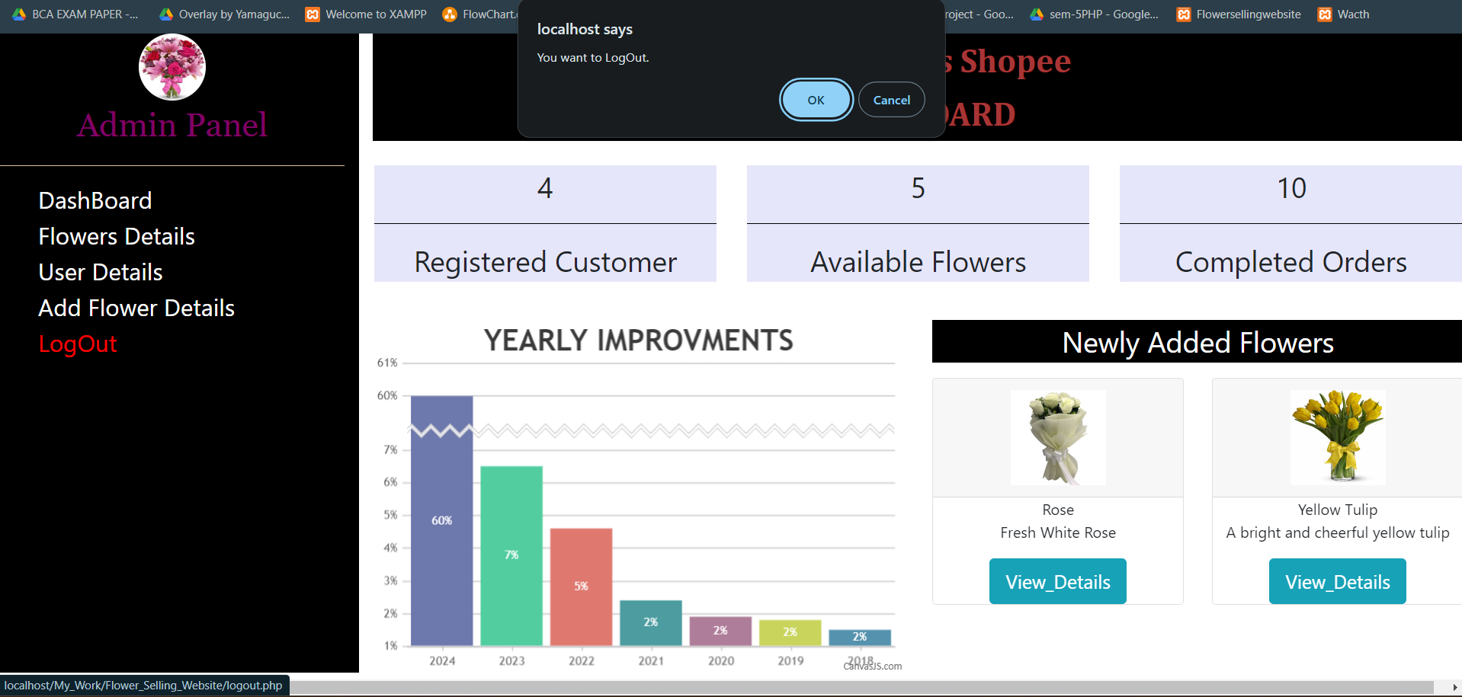

<?php

session_start();

session_unset();

session_destroy();

echo "<script>window.location.href='login.php';</script>";

?>

**User Module**

registration.php

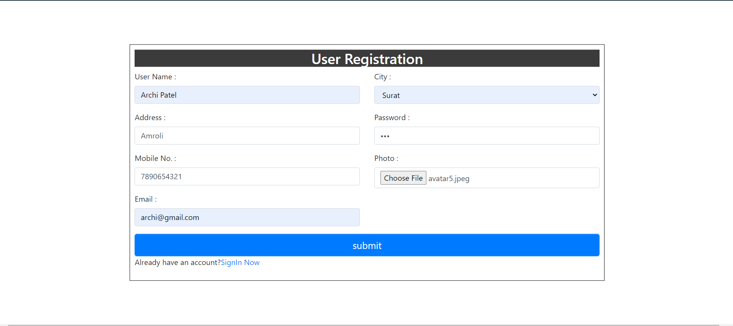

<?php

$con = mysqli_connect("localhost", "root", "", "flower_database");

if (isset($_POST['submit'])) {

    if (!empty($_POST['uname']) && !empty($_POST['add']) && !empty($_POST['mno']) && !empty($_POST['email']) && !empty($_POST['city'])) {

        $uname = $_POST['uname'];

        $add = $_POST['add'];

        $mno = $_POST['mno'];

        $email = $_POST['email'];

        $city = $_POST['city'];

        $pwd = $_POST['pwd'];

        $img = $_FILES['img']['name'];

        move_uploaded_file($img, "upload_img/$img");

        $qry = mysqli_query($con, "INSERT INTO `user_details`(`user_name`, `address`, `mobile_no`, `email`, `password`, `city`, `photo`) VALUES ('{$uname}','{$add}','{$mno}','{$email}','{$pwd}','{$city}','{$img}')");

        echo "<script>alert('Your Data successfully Registered.');

            window.location.href='login.php';

            </script>";

    } else {

        echo "<script>alert('Please Insert all the required data.')</script>";

    }

}

?>

user_navbar.php

<?php

include('config.php');

$sql = "select * from user_details where email='{$_SESSION['mail']}'";

$qry = mysqli_query($con, $sql);

$row = mysqli_fetch_array($qry);

?>

<div class="profile">

                <a href="user_profile.php?uid=<?php echo $row[0]; ?>">

                    <img src='upload_img/<?php echo $row[7]; ?>' alt='image' height='60px' width='60px' class='rounded-circle'>

                </a>

            </div>

user_panel.php

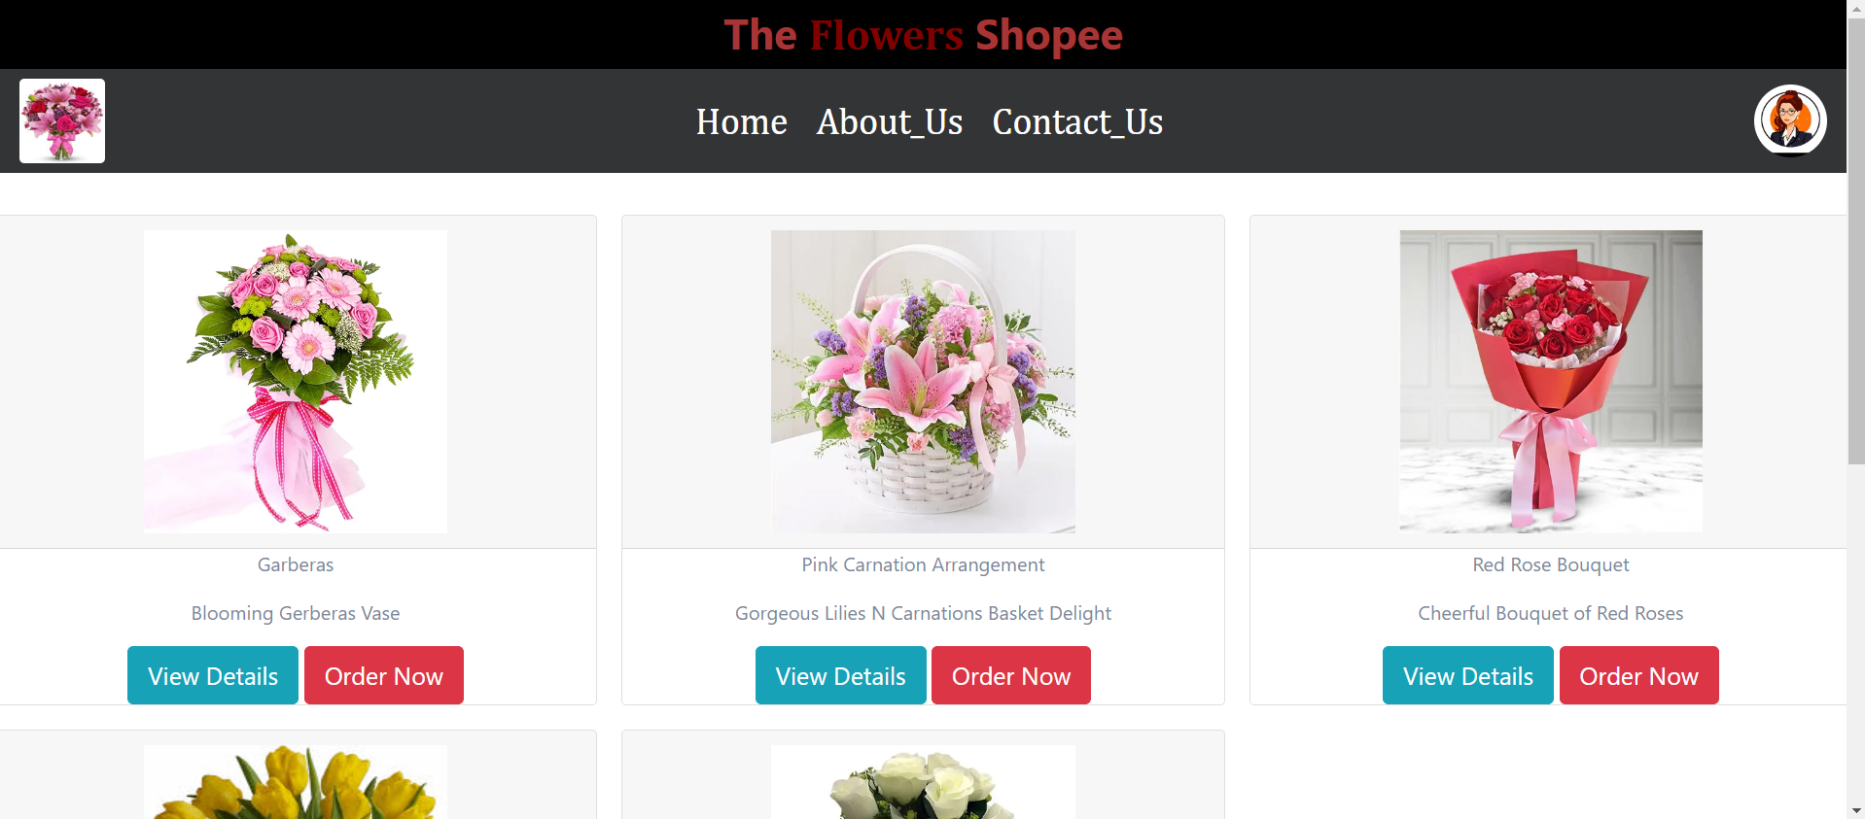

<?php include('user_navbar.php'); ?>

<?php

            $qry = mysqli_query($con, "select * from flower_details");

            while ($row = mysqli_fetch_array($qry)) { ?>

                <div class="col-sm-4 text-center">

                    <div class="card">

                        <div class="card-header">

                    <img src="upload_flower/<?php echo $row['image']; ?>" alt="image" height="250px" width="250px">

                        </div>

                        <div class="card-content">

                        <p><?php echo $row[1]; ?></p>

                    <p><?php echo $row[2]; ?></p>

                    <a href="user_flower_details.php?fid=<?php echo $row[0]; ?>"><button type="button" class="btn btn-lg btn-info">View Details</button></a>

                    <button type="button" class="btn btn-lg btn-danger" onclick="return alert('Your Order Is Successfully Ordered.');">Order Now</button>

                        </div>

                    </div>

                </div>

            <?php } ?>

user_flower_details.php

<?php

$con = mysqli_connect("localhost", "root", "", "flower_database");

if (isset($_REQUEST['fid'])) {

    $fid = $_REQUEST['fid'];

    $qry = mysqli_query($con, "SELECT * FROM `flower_details` WHERE flower_id=$fid");

    $r = mysqli_fetch_array($qry);

}

?>

<?php include('user_navbar.php'); ?>

<div class="col-sm-6">

                        <img src="upload_flower/<?php echo $r['image']; ?>" alt="image" height="400px" width="400px" class="img-thumbnail">

                    </div>

<p>Flower Name : <?php echo $r[1] ?><br>

       Description : <?php echo $r[2] ?><br>

       Price : <?php echo $r[3] ?><br>

       Category : <?php echo $r[5] ?><br>

       Color : <?php echo $r[6] ?><br>

       Stock_Quantity : <?php echo $r[7] ?><br>

       Delivery_Available : <?php echo $r[8] ?><br>

       Delivery_Cost : <?php echo $r[9] ?></p>

<p>

user_profile.php & update_user.php

<?php include('user_navbar.php'); ?>

<div class="profile">

                    <a href="profile.php?uid=<?php echo $row[0]; ?>">

                        <img src='upload_img/<?php echo $row[7]; ?>' alt='image' height='200px' width='200px' class='rounded-circle'>

                    </a>

                </div><br>

                <div id="menu">

                    <a>Hello, <?php echo $row['user_name']; ?></a>

                </div>

<?php

if (isset($_REQUEST['uid'])) {

    $uid = $_REQUEST['uid'];

    $qry = mysqli_query($con, "SELECT * FROM `user_details` WHERE user_id=$uid");

    $row = mysqli_fetch_array($qry);

}

if (isset($_POST['submit'])) {

    if (!empty($_POST['uname']) && !empty($_POST['add']) && !empty($_POST['mno']) && !empty($_POST['email']) && !empty($_POST['city'])) {

        $uname = $_POST['uname'];

        $add = $_POST['add'];

        $mno = $_POST['mno'];

        $email = $_POST['email'];

        $city = $_POST['city'];

        $pwd = $_POST['pwd'];

        $img = $_FILES['img']['name'];

        $old = $_REQUEST['old_img'];

        $temp_img = $_FILES['img']['tmp_name'];

        if (!empty($img)) {

            move_uploaded_file($temp_img, "upload_img/$img");

        } else {

            $img = $old;

        }

        $qry = mysqli_query($con, "UPDATE `user_details` SET `user_name`='{$uname}',`address`='{$add}',`mobile_no`='{$mno}',`email`='{$email}',`password`='{$pwd}',`city`='{$city}',`photo`='{$img}' WHERE `user_id`='{$uid}'");

        echo "<script>alert('Your Information successfully Updated.');

            window.location.href='user_panel.php';

            </script>";

    } else {

        echo "<script>alert('please Insert all the required data.')</script>";

    }

}

?>

about_us.php

<?php include('user_navbar.php'); ?>

contact_us.php

<?php include('user_navbar.php'); ?>

logout.php

<?php

session_start();

session_unset();

session_destroy();

echo "<script>window.location.href='login.php';</script>";

?>